Chicago Parks - Creating Maps Using GIS
(Introductory Lesson)

Authorship
Ryan Miller, Ed.S.

Overview
This skill-building lesson is designed to introduce & reinforce the concepts related to creating maps for analysis using Geographic Information Systems (GIS). ARCGIS.com (“AGO”) will be used as the primary GIS tool. Students will work to develop a research question (RQ) relative to data about Chicago city parks. Trends in the data will be examined spatially across an area selected by the student - referred to as the defined geography. Factors related to potential relationships will be investigated.

Learning Objectives
In this lesson, students will:
- Define spatial and attribute data.
- Identify and add existing data to make maps.
- Learn about symbology – changing the look of features on a map.
- Create map notes to display custom data.
- Filter and display specific data based upon an attribute.

Grade Bands
9th-12th Grade

GIS Skills
- New Skills:
  - Using the “Change Style” icon
  - Filtering Data
  - Searching for and adding data from Living Atlas vs. ArcGIS Online
  - Changing symbology
  - Adding Map Notes
    - Points
    - Lines
    - Polygons
  - Create Buffers
- Prerequisite Skills:
  - Logging into ArcGIS with an account
  - Developing a research question

ArcGIS Tutorial Links
- Creating Maps
  - https://learn.arcgis.com/en/paths/mapping-and-visualization/
- Search and add layers
  - https://doc.arcgis.com/en/arcgis-online/reference/add-layers.htm
- Change Style (Symbology)
  - https://doc.arcgis.com/en/arcgis-online/reference/change-style.htm
- Working with Data
  - https://learn.arcgis.com/en/paths/common-skills-for-working-with-data-arcgis-online/
- Create buffers
  - https://doc.arcgis.com/en/arcgis-online/analyze/create-buffers-mv.htm

Materials and Resources
- Arcgis.com GIS Tools
- Arcgis.com (student) accounts under a school or teacher organization
- Student Materials (print 1 per student or have available digitally)
  - Chicago Parks – Creating Maps Using ArcGIS

Preparation
Prior to teaching this lesson, teachers should:
- Familiarize themselves with the GIS skills being taught in this lesson
- Print student-facing materials or prepare to provide digitally

Teacher Implementation Guide

Activity | Description
GIS data types | Background content knowledge for teacher:  Spatial data is data related to the location (relative to a situation) of an object in both TIME & SPACE and represented on a map.  Attribute data is qualitative and/or quantitative variables that relate to features on a map. Attribute data are about a feature in a location but not related to locating that feature.  Direct students to think of the parks they’ve seen and visited around Chicago. Provide an opportunity for students to list examples relative to various parks visited with respective spatial and attribute data.  **Students can list their examples in journals or on paper, or this can be a whole group activity where the examples are recorded on the white board or chart paper.
Defining “your” geography | GIS analysis requires the user to define a specific geography (a location) from which they will examine and analyze data. In this lesson the focus will be on Chicago park data.  Example inquiry questions to consider as students are directed to define “your” geography:  - How many parks will you focus on?  - Are the locations of the parks in a certain part of Chicago, or are they across the entire city?  - What factors will influence your decision to focus on specific parks?
Developing a potential research question (RQ) | Have students note differences about parks across the City of Chicago.  Inquiry Questions:  - What are some specific characteristics that vary with parks you have visited across the city?  - More importantly, how could you use GIS to study existing surrounding parks to improve the community?  Allow students an opportunity to develop a specific RESEARCH QUESTION (RQ), with focus and purpose, that examines current park conditions or issues in Chicago. Use data and GIS to dive into the question with the hope of finding solutions to potential problems/issues.
Creating a MAP and ADDING data to a map | ArcGIS Guidance:  All options on the left of the map are tools and options to change and/or modify the look of the ENTIRE MAP. All options on the right of the map are tools and options available to change and/or modify the look of a SPECIFIC LAYER.  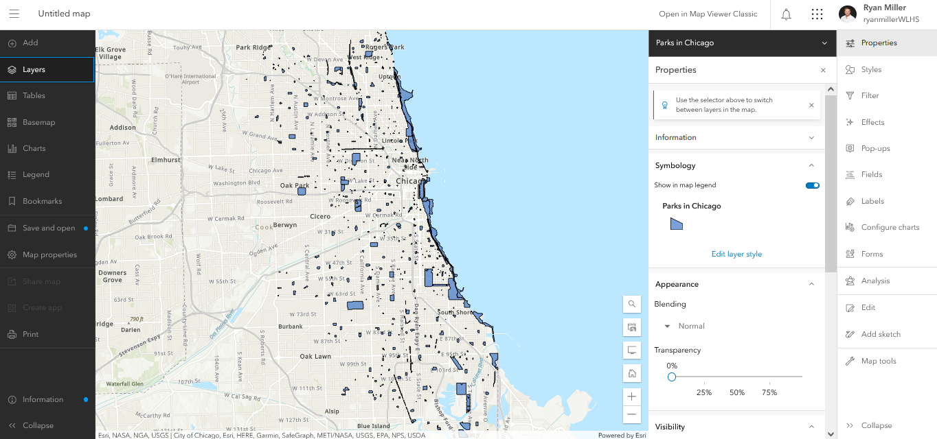  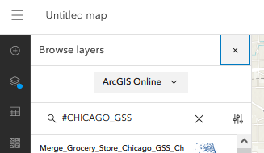  After logging into arcgis.com, browse to the MAP feature. To ADD Data to a map, click on the PLUS icon (image below).  Data already exists in ArcGIS Online related to Chicago City Parks. Search for the Parks in Chicago layer by accessing and searching ArcGIS with the tags: #CHICAGO_GSS and Parks (example below).  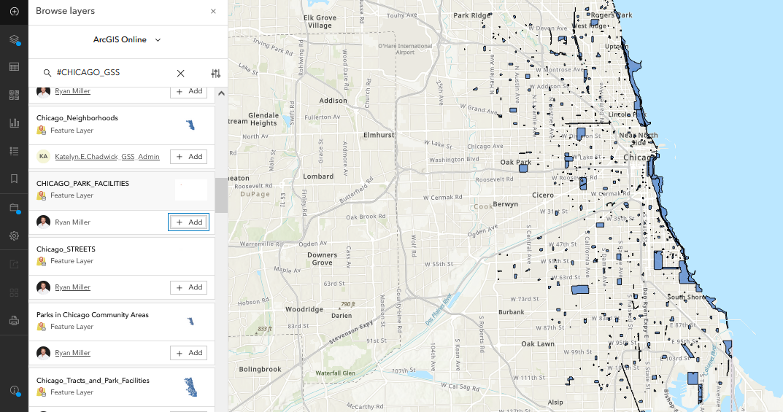  Spatial Data (map above) is now displaying the size, shape, and location of all park facilities in Chicago.  To access attribute data relative to each park, click the layer icon (under ADD) and then the three-dot icon to the right of Parks in Chicago. Show table allows access to the attribute data.  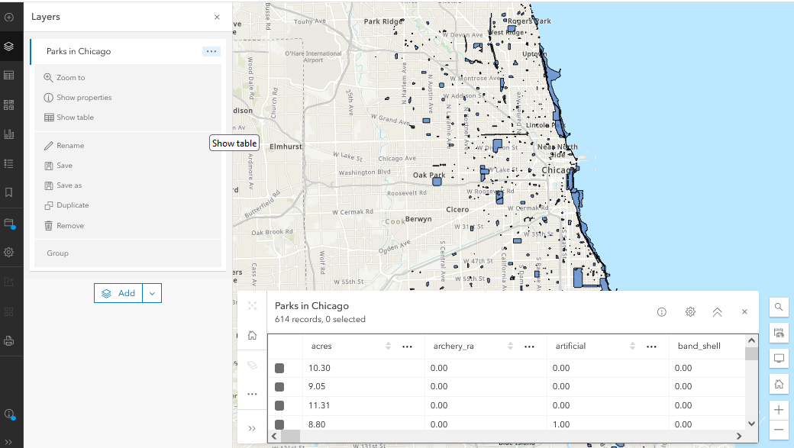  The attribute spreadsheet contains data relative to each park. This includes attributes like park size as well as other features at the park. This data may assist with the development of the student’s RQ.
Modifying Map  (Teacher guidance) | Adding Data:  After reviewing the attribute data associated with the Parks in Chicago layer, have students explore the options available to change the symbology of the various parks in the city as well as the filter tool and show specific parks based upon an attribute selected.  The change style icon, is accessible when clicking on an individual layer, and it allows the user to change the appearance of any layer displayed on the map.  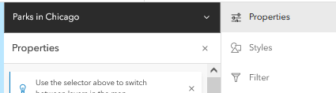  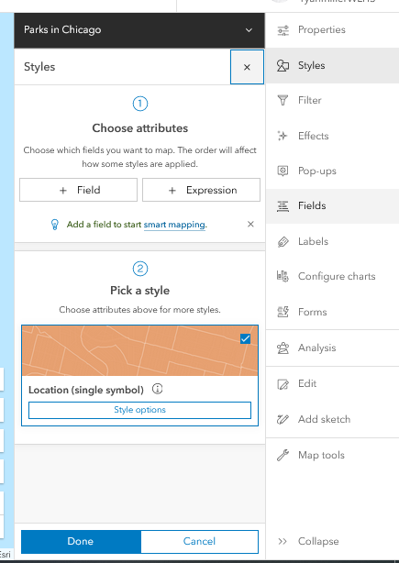  Changing Styles  Under BLUE prompt 1, options are available to show the location of the look of the symbols representing each layer.  Filter Data  The filter tool allows the user to choose to display parks by setting certain conditions. The example below allows the user to find and display ONLY the parks in Chicago that have 1 or more Skate Parks at the facility.  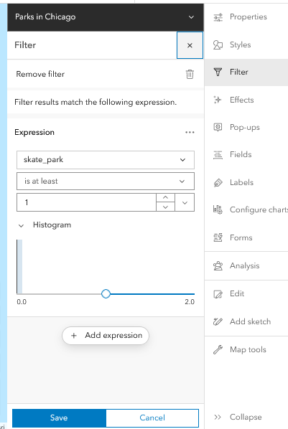  Adding a SKETCH (formerly called a Map Note):  A sketch is a way to customize items added to a map by inserting points, drawing lines, or drawing polygons onto a map.  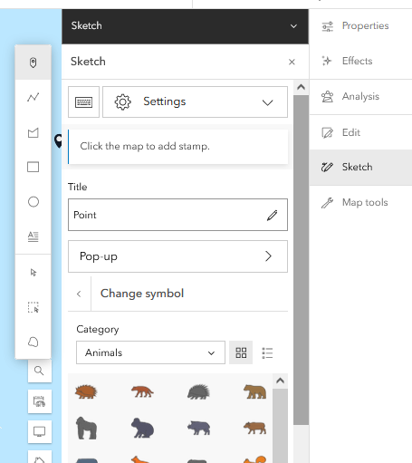  They are accessed by clicking the Sketch Tool on the right menu. The user can determine the type of sketch to make (point, line, polygon) and can custom locate and change the look of the sketch to meet the needs of the map maker. Sketches can be named accordingly -- the symbology of each map note can be modified by following the provided AGO prompts.
Student work time | **See below for student-facing materials and instructions  Student Tasks:  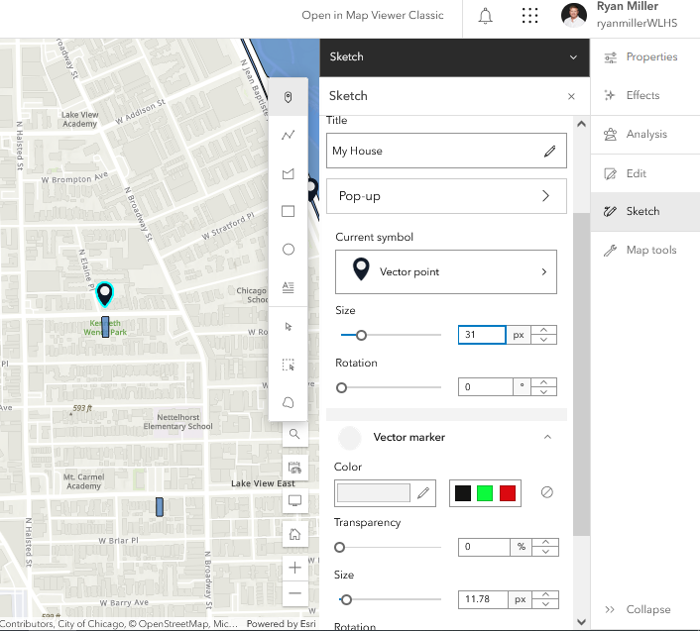  - Find the location they live in Chicago. Use and +ADD a SKETCH (POINT) to mark this location.  - After the location of the student’s house has been placed on the map. Click on the sketch layer to activate the menu on the right of the Map.  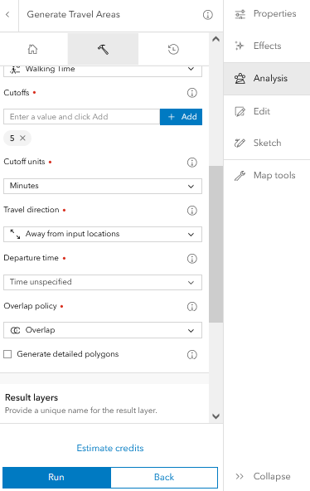  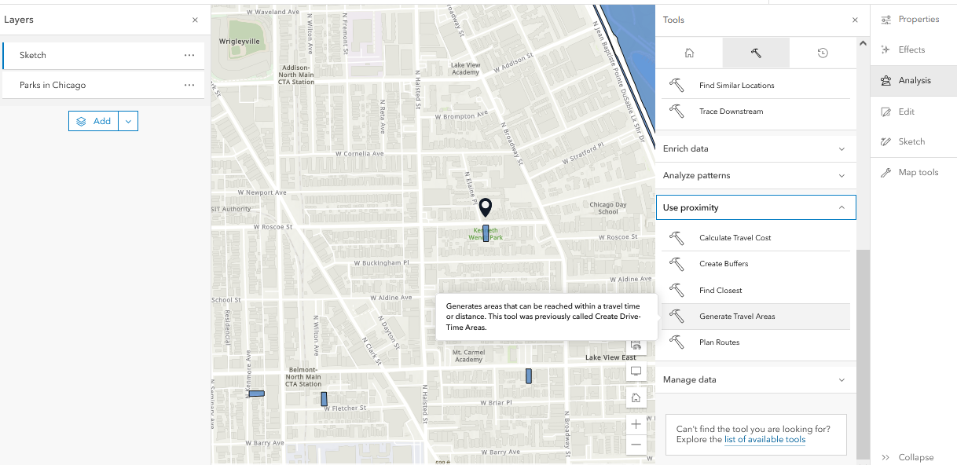  By clicking on Analysis on the right menu, browse to the Hammer (TOOL) icon at the top. Browse to the Use Proximity Section of the Tools. Select Generate Travel Areas. Students can then adjust the settings to WALKING TIME, ADD 10 Minutes to the cutoff time. Provide a unique name to the Result Layer that will be generated. Example: MYhouse_10MIN. Hit Run.  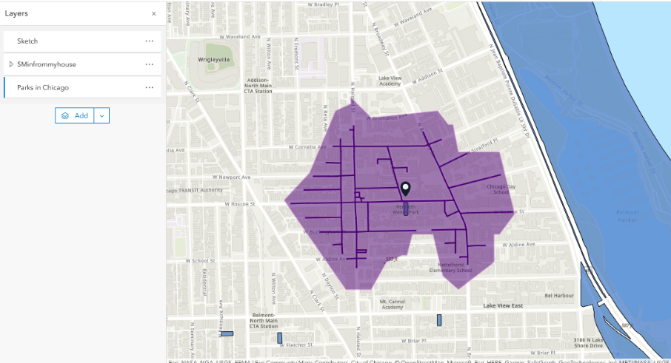  The result will be a polygon surrounding the point of the student’s house that represents the locations that can be reached with walking 10 minutes in any direction:  - The Student can then determine if or how many parks are within a 10 minute walk from their home.  - Change the symbology of the parks to properly convey the location of parks within a 10-minute walk from their home.  - Save all work for continued use if needed.

Assessment
Students should work to create a map similar to the map below. It includes a sketch of a point representing their home/apartment, etc. A sketch of text that indicates their home. A polygon area representing the locations reachable by walking 10 minutes in any direction (including streets) and the location of parks within this 10-minute area.
By saving their map in AGO, students can then print it to pdf and export the pdf for assessment.
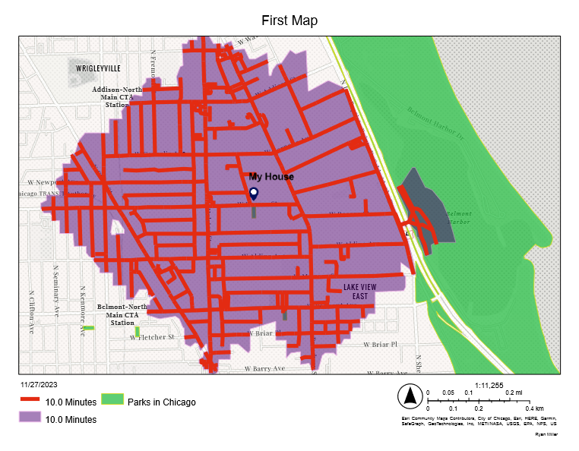
Student-Facing Materials
Creating Maps Using ArcGIS STUDENT

Name: __________________________________________ Date: _____________________

Chicago Parks - Creating Maps Using GIS

You will work to develop a research question relative to data about Chicago city parks and then examine trends in the data spatially across an area you specifically choose (defined geography).

- GIS Data Types – Develop definitions for the following vocabulary:
a) Spatial data:
__________________________________________________________________________________________
__________________________________________________________________________________________
__________________________________________________________________________________________
b) Attribute data:
__________________________________________________________________________________________
__________________________________________________________________________________________
__________________________________________________________________________________________

- Think of the parks you’ve seen and visited around Chicago. List examples relative to respective spatial and attribute data of these parks.

Data Type | Examples
Spatial Data
Attribute Data

- Defining “Your” Geography
GIS analysis requires you to focus on a specific area.

- How many parks will you focus on?

__________________________________________________________________________________________
__________________________________________________________________________________________
__________________________________________________________________________________________

- Are the locations of the parks in a certain part of Chicago, or are they across the entire city?

__________________________________________________________________________________________
__________________________________________________________________________________________
__________________________________________________________________________________________
__________________________________________________________________________________________

- What factors will influence your decision to focus upon specific parks?

__________________________________________________________________________________________
__________________________________________________________________________________________
__________________________________________________________________________________________
__________________________________________________________________________________________
- What is your DEFINED GEOGRAPHY?
__________________________________________________________________________________________
__________________________________________________________________________________________
__________________________________________________________________________________________
__________________________________________________________________________________________
__________________________________________________________________________________________
__________________________________________________________________________________________
__________________________________________________________________________________________
__________________________________________________________________________________________
__________________________________________________________________________________________
- Developing your Research Question
Use the following prompts to help create your research question:
  - What differences about parks across the City of Chicago can you think of?
  - What are some specific characteristics that vary with parks you have visited across the city?
  - More importantly, why do these differences exist and how could GIS help to study this situation to improve your community?

RESEARCH QUESTION (RQ) (remember focus and purpose):
__________________________________________________________________________________________
__________________________________________________________________________________________
__________________________________________________________________________________________
__________________________________________________________________________________________
__________________________________________________________________________________________
__________________________________________________________________________________________
- Getting Chicago Park GIS Data
Search ArcGIS Online with the tags: #CHICAGO_GSS and Parks for available data related to parks in Chicago. Choose the layers to work with and add them to your map.
- Creating Maps
Practice adding, filtering, and displaying data by recreating the map below. Have your teacher check you off before you proceed. Hints: the selected parks displayed below have 10 or more basketball courts at the location.
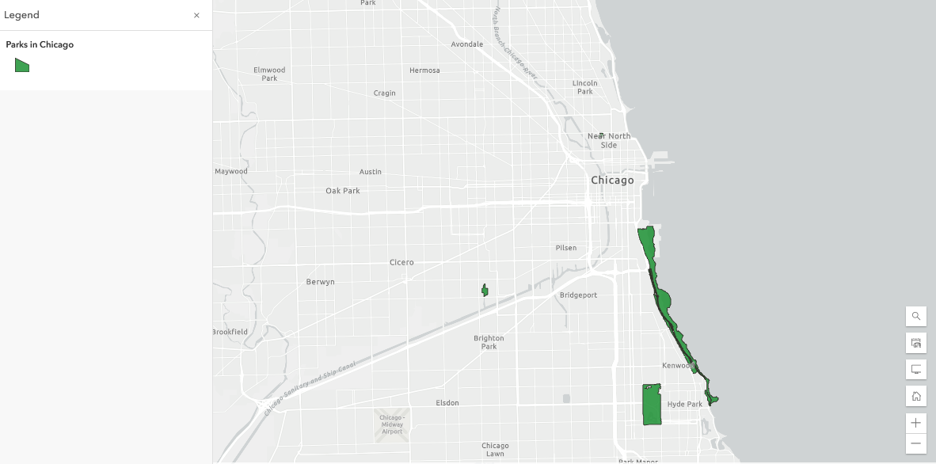
Steps to Create Your Map

- Find the location where you live in Chicago. Use and ADD a SKETCH to mark this location (POINT).
- Click on Analysis (RIGHT MENU), choose the Use Proximity Toolset and Generate Travel Areas to create a new layer that identifies all locations within a 10-minute walk from your SKETCH (your home).
- Identify the number of parks that are within the 10-minute walk polygon.
- Change the symbology of the parks to properly convey the location of parks on the map.
- Save all work.

Data Layers for this assignment include:
- CHICAGO PARK FACILITIES (Found using #CHICAGO_GSS and Parks in AGO)
- Parks in Chicago (Found using #CHICAGO_GSS and Parks in AGO)

