Mapping My Community
(Introductory lesson)

Authorship
Ryan Miller, Ed.S.

Overview
In this lesson, students will learn the definition of a mental map and create their own mental map of the community they reside in by sketching a map by hand. They will then use GIS to create a digital mental map. In small groups, students will compare mental maps to consider how they differ and what factors (e.g. access to transportation) may shape what areas they know and do not know.

Learning Objectives
In this lesson, students will:
- Create a mental map on ArcGIS
- Compare and contrast the factors that influence what a person knows about their geography

Grade Bands
9th – 12th Grade

Standards

CCSS.ELA-LITERACY.RST.9-10.4 / CCSS.ELA-LITERACY.RST.11-12.4: Determine the meaning of symbols, key terms, and other domain-specific words and phrases as they are used in a specific scientific or technical context relevant to grades 11-12 texts and topics.

CCSS.ELA-LITERACY.SL.9-10.5 / CCSS.ELA-LITERACY.SL.11-12.5: Make strategic use of digital media (e.g., textual, graphical, audio, visual, and interactive elements) in presentations to enhance understanding of findings, reasoning, and evidence and to add interest.

CCSS.ELA-LITERACY.WHST.9-10.6 / CCSS.ELA-LITERACY.WHST.11-12.6: Use technology, including the Internet, to produce, publish, and update individual or shared writing products, taking advantage of technology's capacity to link to other information and to display information flexibly and dynamically.

GIS Skills
- Prerequisite Skills
  - How to log into ArcGIS
- New Skills
  - Adding spatial features as SKETCHES (points, routes, polygons, text)
  - Changing Symbology of layers
  - Creating and sharing feature layers
  - Integrating map layers from different sources

ArcGIS Tutorial Links
- Creating Maps
  - https://learn.arcgis.com/en/paths/mapping-and-visualization/
- Changing Style (Symbology)
  - https://doc.arcgis.com/en/arcgis-online/reference/change-style.htm
- Sharing Maps
  - https://learn.arcgis.com/en/paths/sharing-and-collaboration/
- Searching and adding layers
  - https://doc.arcgis.com/en/arcgis-online/reference/add-layers.htm

Materials and Resources
- Arcgis.com (student) accounts under a school or teacher organization
- Student Materials pages printed or available digitally
  - Comparing your Sketched Map with your Digital Map
  - Comparing Group Member’s Maps
  - Student Guide – Adding SKETCHES (Points, Lines, Polygons) and Changing Symbology
  - Student Guide – Combining Map Layers into Group Map
- Paper and pencil

Preparation
Prior to teaching this lesson, teachers should:
- Print Student Materials (or prepare to provide digitally)
- Familiarize themselves with the ArcGIS skills

Teacher Implementation Guide

Activity | Description
What is a Mental Map? | Introduce the concept of a mental map  - A subconscious map that shows what a place looks like and how to interact with it  - How one navigates from place to place without the help of technology or physical maps  Provide examples of what can be included in a mental map  - Where towns, states, and countries are located in comparison to one another  - How to get to the grocery store from your house  - The journey to get to school  Possible discussion question:  - Does everyone have mental maps, and if they do, how are they formed?
Sketching a mental map | Students will sketch a mental map of the community they live in on a piece of paper without using any mapping programs.  Criteria:  - Include locations of where you visit most (home, parks, school, restaurants, etc.)  - Include the routes taken to get to familiar places (train or bus line, driving routes, walking paths, etc.)  - Designate where you feel safe traveling versus not safe traveling  - Create boundaries that show the farthest you have traveled within your community by foot, public transportation, or by car  - Take of picture of the sketch when finished
Creating a mental map on ArcGIS and mental map discussion | 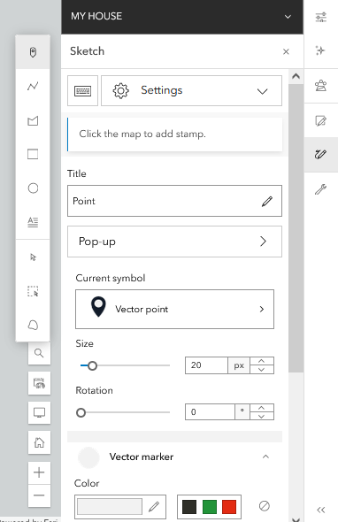  Students will create a digital mental map in ArcGIS Online [arcgis.com]. Assign each student a color to use when creating their objects as SKETCHS in AGO. As they work on their individual maps, encourage students to collaborate to figure out how to apply the GIS techniques to their projects. Provide support and answer questions as needed. Students will use the guiding questions on the student handouts to analyze their individual maps.  Guiding questions:  - How easy was it to translate your sketched mental map to your GIS map?  - How accurate was your sketched map when comparing it to your GIS map?  - Did your perceptions of distance and direction change as you compared your two maps?  - Looking at your GIS map, what do the places you go to most say about your present lifestyle?  - What factors influence the places you go to and how you get there?  - What is your major mode of travel within your community? How does that influence where you have traveled?  - Examine the areas that you consider safe and not safe to travel. What is it about those areas that makes you feel that way?  - If you were to show this map to someone who is unfamiliar with where you live, what impression would they have of the community shown on the map? Would they be correct?  - Change the basemap to imagery with labels. Were there any locations that you left out and would like to include in your map if you could?  Criteria to be included on the mental map: point, line, and polygon SKETCHES that represent locations, routes, and areas that were drawn on the sketched mental map.  After completing their individual GIS maps, students will form groups of 2-3 and compare their maps. Make sure that each student in a group used a different color for their GIS map. Students will engage in a discussion with their group members utilizing the questions on the student materials.  Group discussion questions:  1. How are your group members’ maps similar? How are they different?  2. Are most of the frequently visited places common for the majority of your group members? Are there any places you considered important for your map but were not as important for others?  3. How does the mode of transportation affect how far and where you have traveled? Are there any people in your group that consider themselves experienced using public transportation? How are their maps different?  4. How are areas considered safe versus unsafe for everyone in the group? What might influence how the safety of an area is perceived?  5. Was there any debate within your group when discussing mental maps? Did anyone in the group have perceptions of places they have never been and/or seen that others HAVE been to that created conflicts within the group?
GIS Instructions  (also available as a student handout) | Adding SKETCHES (Points, Lines, Polygons) and Changing Symbology (formerly called “map notes”)  In a new blank map, zoom in to the area you drew in your mental map. Create a digital version of your mental map by adding SKETCHES for the different features you drew. NOTE: Sketches can be accessed on the menu right of the map in arcgis.com.  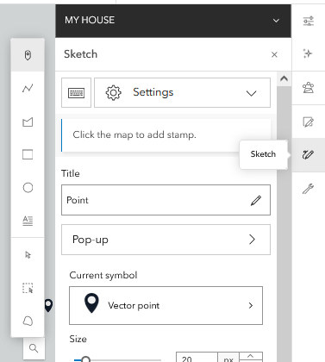  Name the SKETCH.  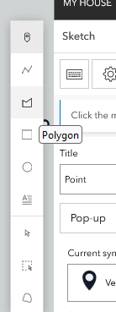  Several different types of SKETCHES can be added to a map. The main types are POINTS, LINES, and POLYGONS. The options of the type are in the image to the right.  *Pay attention to the popup instructions for how to create each type of feature.  After creating a feature, you will give it a title and an optional description for more detail.  All options to change the look (“SYMBOLOGY”) of any sketch added to a map are provided in the menu that pops-up on the right after the sketch is added to a map. Image BELOW:  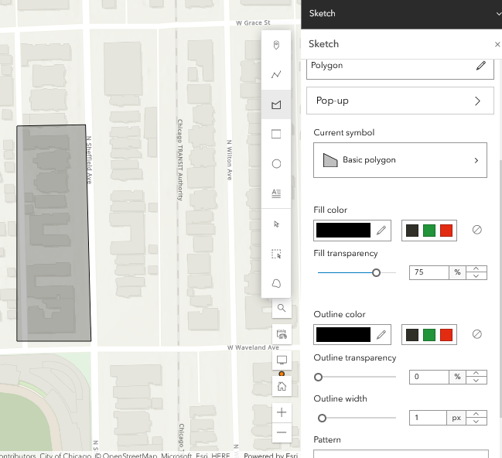  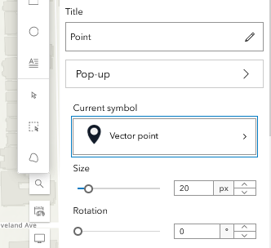  When using point features, CLICK ON “CURRENT SYMBOL” to adjust the look of any added point. Optional: students may also choose to explore other symbol categories to be more creative with their maps.  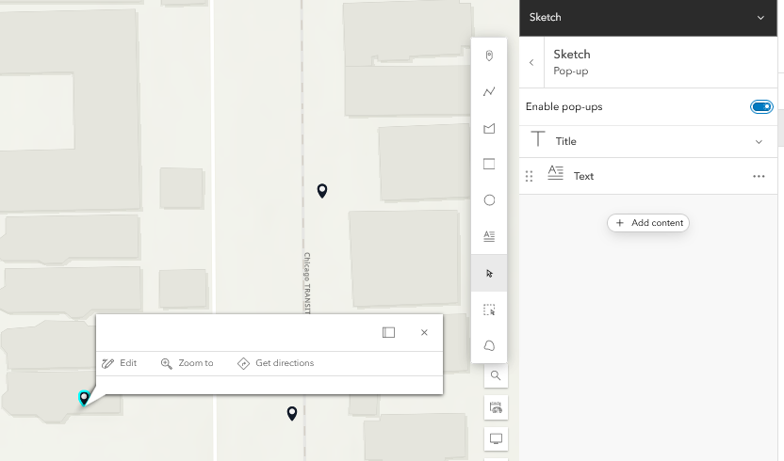  When you have finished adding your SKETCHES, simply click the X on the top right of the right menu.  You can enable pop-up descriptions to display for any sketch by enabling the the pop-up feature in the image to the right:  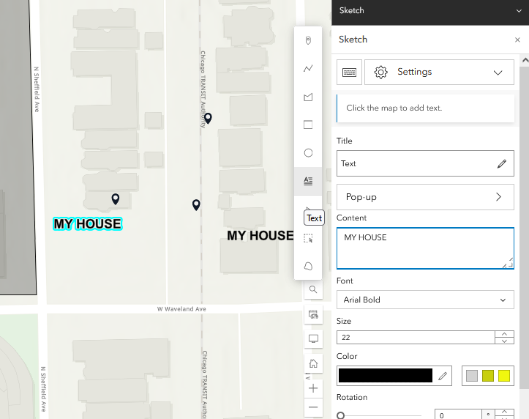  If you want to see labels displayed on the map without clicking, you can add a text sketch. This is one of the options provided in the SKETCH menu.  You can also change the direction of text by clicking the top center box encircling the text when it’s selected.  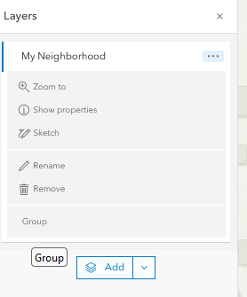  Save your map (menu on the LEFT).  SHARING SKETCHES FOR COLLABORATION. SAVE then SHARE.  Once several sketches have been added to your map, you can GROUP the sketches and share the availability of the sketches with others.  SAVE  Click on Layers (LEFT MENU).  Navigate to the sketch layer and select GROUP. (IMAGE TO RIGHT).  This then provides an option to SAVE AS (bottom image).  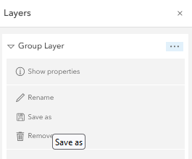  Once the SAVE AS MENU APPEARS the sketch layer can be saved in the account of the person logged into AGO.  They will save a new copy of their map using “Save As” and giving it a new name.  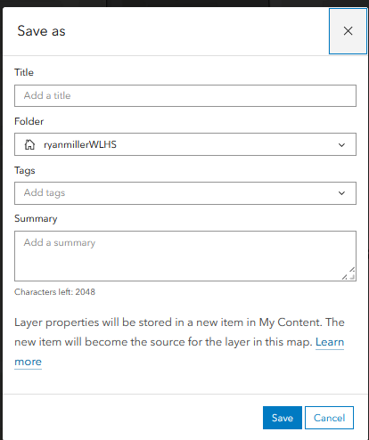  SAVE AS will save the sketches as layers in the account of the user for future access.  Tags can be added to all saved layers, if a group wants to make it easier to access saved and shared layers, they can agree upon a common tag.  SHARE  After saving the layer, it is accessible by visiting the CONTENT section in AGO. TOP of screen and circled in the image below. Browse to the layer you saved in the account. Then hit SHARE (right side of the image below to choose how you prefer to share work created with others. At a minimum, work should be shared with YOUR ORGANIZATION to allow for access by others in the class.  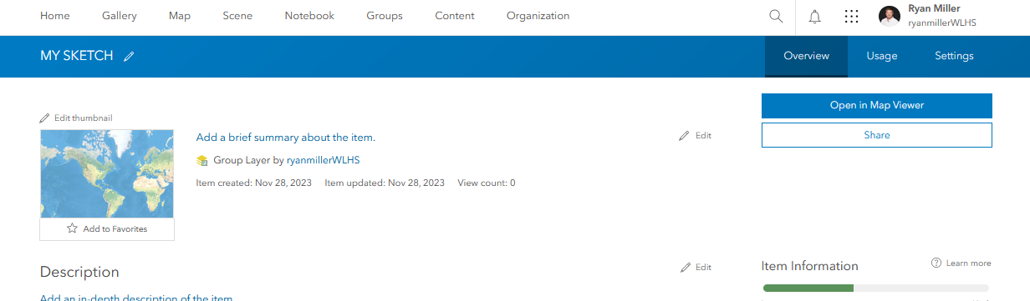  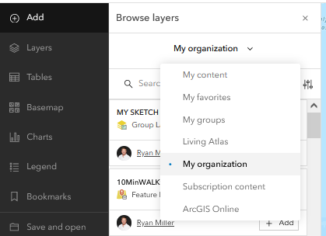  If you have any features that overlap, you can drag them to change the order in the table of contents, to improve visibility.  Other members of the organization can now go to MAP, choose to ADD a layer and use “My Organization” as the database to search. The saved sketch layer from earlier will then be available to add to another map.

Assessment:
  - Are there similarities between the student’s digital mental map and with their sketched version?
  - Did the student include the required criteria?

Student-Facing Resources:
Mapping My Community – Creating Mental Maps STUDENT
Name: __________________________________________ Date: _____________________

Comparing your Sketched Map with your Digital Map

Consider the following questions after you create your map:

- How easy was it to translate your sketched mental map to your GIS map?
__________________________________________________________________________________________________________________________________________________________________________________________________________________________________________________________________________________________________________________________________________________________________________________________________________________________________________________________________

- How accurate was your sketched map when comparing it to your GIS map?
__________________________________________________________________________________________________________________________________________________________________________________________________________________________________________________________________________________________________________________________________________________________________________________________________________________________________________________________________

- Did your perceptions of distance and direction change as you compared your two maps?
__________________________________________________________________________________________________________________________________________________________________________________________________________________________________________________________________________________________________________________________________________________________________________________________________________________________________________________________________

- Looking at your GIS map, what do the places you go to most say about your present lifestyle?
____________________________________________________________________________________________________________________________________________________________________________________________________________________________________________________________________________________________________________________________________________________________________________________________________________________________________________________________________________________________________________________________________________________________

- What factors influence the places you go to and how you get there?
____________________________________________________________________________________________________________________________________________________________________________________________________________________________________________________________________________________________________________________________________________________________________________________________________________________________________________________________________________________________________________________________________________________________

- What is your major mode of travel within your community? How does that influence where you have traveled?
____________________________________________________________________________________________________________________________________________________________________________________________________________________________________________________________________________________________________________________________________________________________________________________________________________________________________________________________________________________________________________________________________________________________

- Examine the areas that you consider safe and not safe to travel. What is it about those areas that makes you feel that way?
____________________________________________________________________________________________________________________________________________________________________________________________________________________________________________________________________________________________________________________________________________________________________________________________________________________________________________________________________________________________________________________________________________________________

- If you were to show this map to someone who is unfamiliar with where you live, what impression would they have of the community shown on the map? Would they be correct?
____________________________________________________________________________________________________________________________________________________________________________________________________________________________________________________________________________________________________________________________________________________________________________________________________________________________________________________________________________________________________________________________________________________________

- Change the basemap to imagery with labels. Were there any locations that you left out and would like to include in your map if you could?
____________________________________________________________________________________________________________________________________________________________________________________________________________________________________________________________________________________________________________________________________________________________________________________________________________________________________________________________________________________________________________________________________________________________

Name: __________________________________________ Date: _____________________

Comparing Group Member’s Maps

Combine your group’s map layers together into a single map.

As you compare you maps, consider the following points:

- How are group members' maps similar? How are they different?
____________________________________________________________________________________________________________________________________________________________________________________________________________________________________________________________________________________________________________________________________________________________________________________________________________________________________________________________________________________________________________________________________________________________

- Are the most frequently visited places common for everyone in your group? Are there any
places that you considered important but were not on anyone else’s map?
____________________________________________________________________________________________________________________________________________________________________________________________________________________________________________________________________________________________________________________________________________________________________________________________________________________________________________________________________________________________________________________________________________________________

- How does the mode of transportation affect how far and where you have traveled? Do any group members consider themselves experienced with using public transportation? How are their maps different?
____________________________________________________________________________________________________________________________________________________________________________________________________________________________________________________________________________________________________________________________________________________________________________________________________________________________________________________________________________________________________________________________________________________________

- How are areas considered safe versus unsafe for everyone in the group? What might influence how the safety of an area is perceived?
____________________________________________________________________________________________________________________________________________________________________________________________________________________________________________________________________________________________________________________________________________________________________________________________________________________________________________________________________________________________________________________________________________________________

- Was there any debate within your group when discussing mental maps? Did anyone in the group have perceptions of places they have never been and/or seen that others HAVE been to that created conflicts within the group?
____________________________________________________________________________________________________________________________________________________________________________________________________________________________________________________________________________________________________________________________________________________________________________________________________________________________________________________________________________________________________________________________________________________________

Student Guide - Adding SKETCHES (Points, Lines, Polygons) and Changing Symbology

In a new blank map in AGO, zoom in to the area you drew in your mental map.

Create a digital version of your mental map by adding SKETCHES to represent the different features you drew.

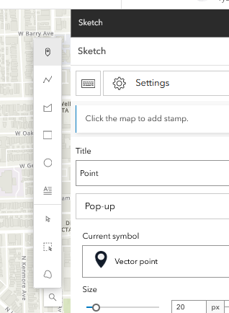
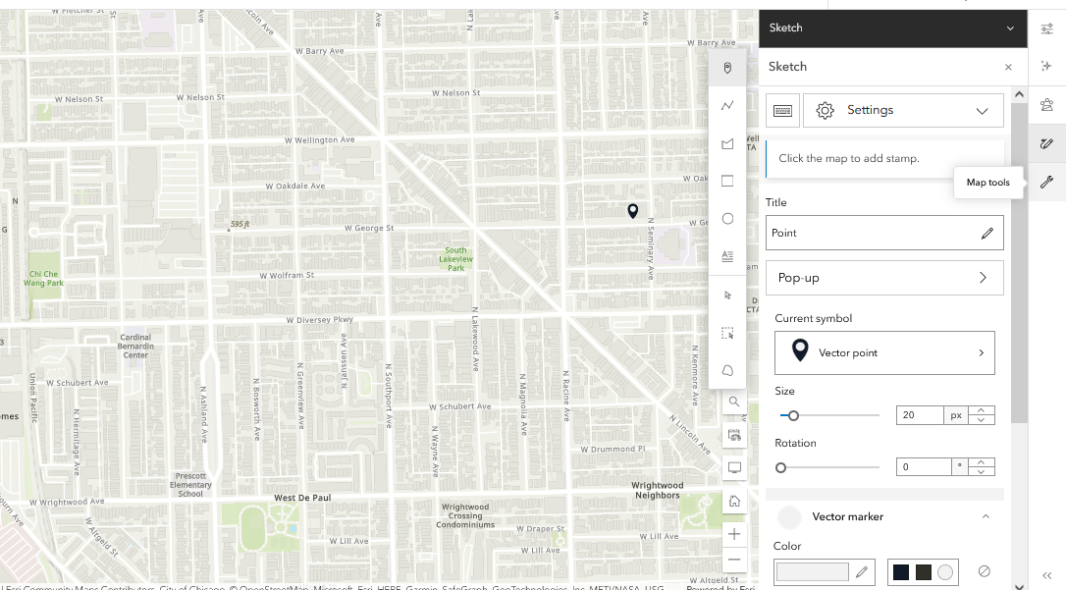

Name the layer.
This layer will contain all the different SKETCHES you create, so give it a general name.

Options to SKETCH points, lines, polygons and text appear on the right side of the screen. Circled in RED

Select the appropriate feature type for what you are adding to the map.

*Pay attention to the popup instructions for how to create each type of feature.
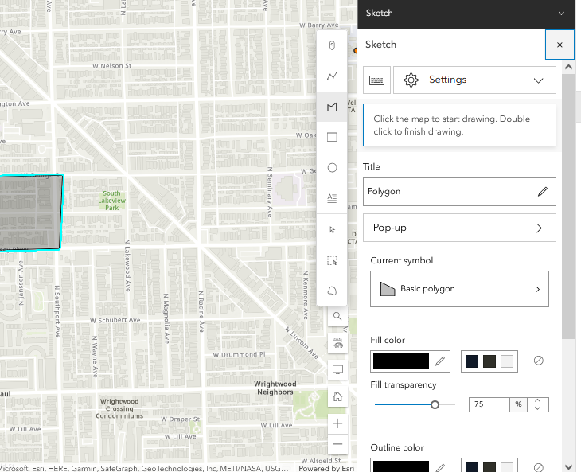
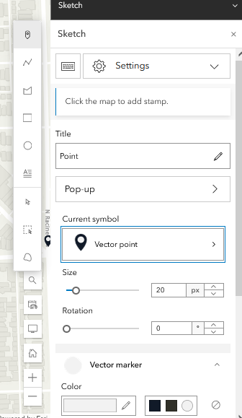
After creating a feature, you will give it a title and an optional description with more detail. You can change the look (“SYMBOLOGY”) of your sketch as you see fit. Click on “Pop-Up” to allow the feature to be clicked on to display information.

When using point features, you can change the SYMBOLOGY of the point by selecting the options near “Current symbol” and change the look of points you are sketching to your map.

When you have finished adding your SKETCHES, click “X” to return to the view of your map and to exit the properties of your sketches.

If you want to return to edit or add more to your SKETCHES, click Layers (LEFT MENU), select the SKETCH and click on “Show Properties.”

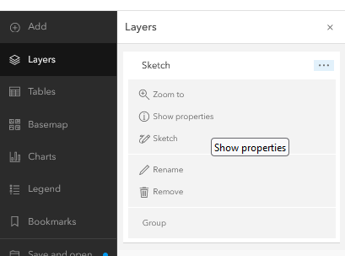

You can view the label and description for map note features by clicking on them. (REMINDER: “Pop-Ups” need to be enabled for your sketch and they need to have the properties adjusted, first.)

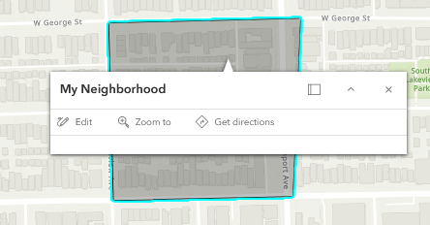
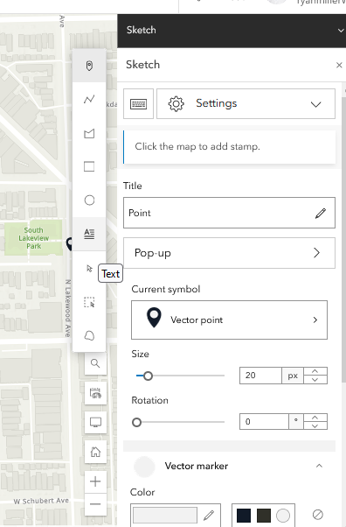
If you want to see labels (text) displayed on the map without clicking, you can add TEXT SKETCH:

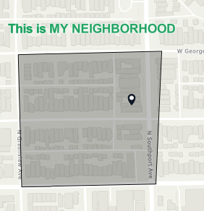

Adding a halo to your text is a good way to make sure it’s visible.

Save your map, tagging it with the class hashtag.

Student Guide - Combining Map Layers into Group Map

After you have finished using SKETCHES to create your digital mental map, save your collection of SKETCHES as a Layer.

First click on Layers on the LEFT MENU. Click on the PROPERTIES of the SKETCH, SELECT GROUP
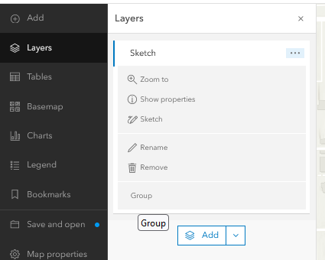

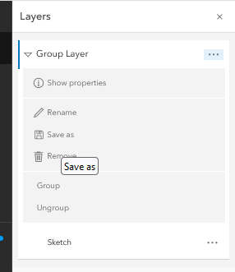
Click on and expand the GROUP LAYER (image to right) and choose “Save as.”
The layer will be saved in “My Content” in AGO. You will now have this map layer as a published feature layer in “My Content”. By default, the sharing level is set to Owner, which means that other people cannot find it.
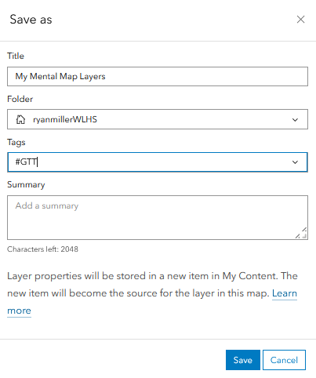

Browse on AGO to CONTENT, find your saved layer of sketches, click on it. You must change the sharing level to “Organization” so your classmates can access your layer. Under the layer options, select “Show Item Details.” On the details page, click “Share”, and set the sharing level to “Organization.”
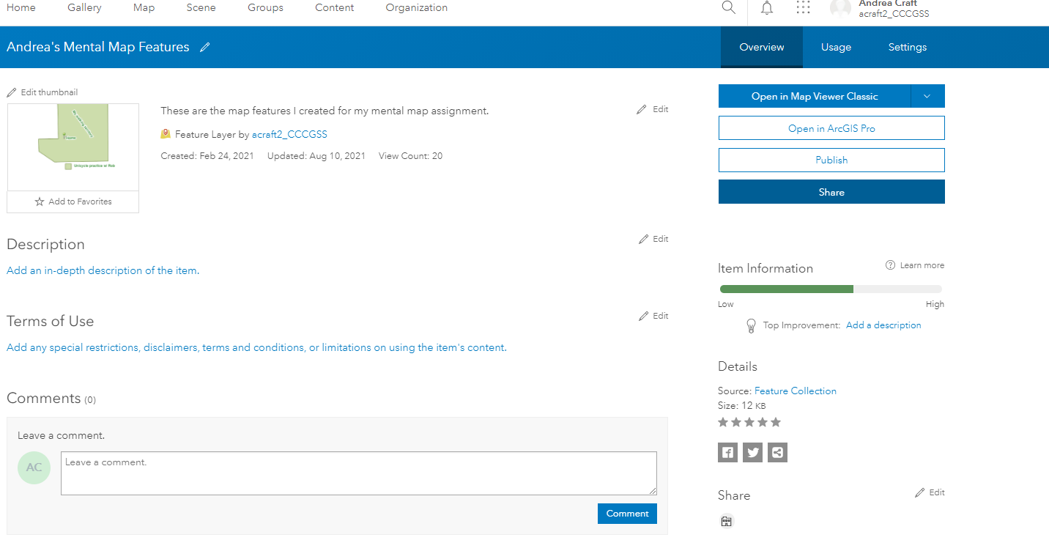

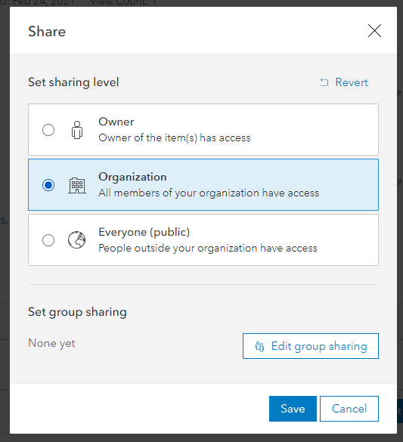

Once every member of the group has SAVED and SHARED their sketches, choose one group member to be in charge of hosting the group’s collaborative map.

Create a NEW MAP on the host’s account. Browse and find in “My organization” all of the sketched layers that had been previously saved. ADD all member’s sketch layers to your collaborative map.
They will save a new copy of their map using “Save As” and giving it a new name.

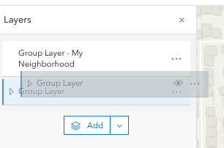
If you have any overlapping features, you can drag them to change the order in the table of contents. (think like they are sheets of paper getting stacked).

