Map that Recipe!
(Intermediate Lesson)

Authorship:
Chris Bunin
*Lesson designed and created around the Survey123 tutorial in the textbook, GIS for Teachers (2017, Carte Diem Press)

Overview
This lesson will allow students to analyze the geographic impact of the Columbian Exchange. They will consider diffusion patterns of various foods and explain both positive and negative effects of the Columbian Exchange. As a culminating activity, the students will research, plot, and create a StoryMap about a recipe of their choosing.

Learning Objectives
In this lesson, students will:
- Use ArcGIS Online to analyze and explain the diffusion patterns of potatoes, corn, and bananas as part of the Great Exchange.
- Identify and explain some of the positive and negative effects of the Columbian Exchange.
- Research, plot, and Story Map the historical geography of a recipe of their choice (at least 7 ingredients).

Grade Bands
9th – 12th Grade

GIS Skills
- Prerequisite Skills
  - Create a map
  - Add layers
- New Skills
  - Creating sketch notes
  - Creating a StoryMap
  - Calculate Travel Cost (formerly Origin to Destination)
  - Summarize Within

ArcGIS Tutorial Links
- Creating maps
  - https://learn.arcgis.com/en/paths/mapping-and-visualization/
- Adding layers
  - https://doc.arcgis.com/en/arcgis-online/reference/add-layers.htm
- Adding Sketch Notes
  - esri.com/arcgis-blog/products/arcgis-online/mapping/note-this-sketching-now-available-in-map-viewer/
- Summarize Within
  - https://doc.arcgis.com/en/arcgis-online/analyze/summarize-within-mv.htm
- Calculate Travel Cost
  - https://doc.arcgis.com/en/arcgis-online/analyze/calculate-travel-cost-mv.htm
- StoryMaps
  - https://learn.arcgis.com/en/projects/share-the-story-of-an-expedition/

Materials and Resources
- Classroom set of laptop computers
- ArcGIS Online Organizational Accounts (enough logins for students)
- Esri’s Great Exchange GeoInquiry https://esriurl.com/historyGeoInquiry15
- Esri’s Great Exchange GeoInquiry Student Worksheet (make a copy and then print)
- Student Materials
  - Map that Recipe! Day 1
  - Map that Recipe! Day 2
  - 3-2-1 Peer Feedback worksheet

Preparation
- To complete this lesson a teacher needs to be comfortable using ArcGIS Online to create a Survey123 app, ArcGIS Online map, and StoryMaps.
- Familiarize yourself with the ArcGIS Online interface, the Great Exchange GeoInquiry, the Survey123 directions, ArcGIS Online analysis tools, and creating ArcGIS Online Story Maps.
- If needed, set up an ArcGIS Online Organizational Account for your school/classroom.
- Use Survey123 to create a “Map that Recipe!” Survey and ArcGIS Online map that contains two layers – Recipe Hearths and Ingredient Hearths. Make sure the web map sharing is set to allow student to have access to the data and the map (directions are provided below).

Teacher Implementation Guide

Activity | Description
Day 1 – Researching a recipe | 1. Introduce the lesson by completing the Esri GeoInquiry, The Great Exchange. You can complete this activity as a teacher-led activity with one computer or give students time to complete the activity on their own before discussing the mapping results.  **As you review the activity with students, reinforce the impact the age of European exploration had on world geography and culture – particularly food and recipes.  2. Ask students to think about and answer the following questions:  Q1 – What is your favorite recipe/dish?  Q2 – When were you introduced to this recipe?  **Students can write down their responses to these questions or just think and discuss.  3. Have students think/pair/share their responses.  4. Explain to students that they will be researching and plotting the origins of the ingredients of their favorite recipe on the “Map that Recipe!” AGO Map.  **Suggested steps for this part:  - Have everyone use Google or another search engine to find a recipe of their favorite dish. Search for your own to model the activity. The recipe should have at least 7 ingredients that will need to be researched.  - Next, have everyone find the first ingredient in their recipe and conduct an internet search to find out where the first <ingredient> was grown and/or domesticated.  - After finding the ingredient, plot the location using the Map that Recipe Survey.  - Model how to do this for 2-3 ingredients to make sure students understand the process.  5. Provide students with work time to research and plot the ingredients of their favorite recipe using the Survey you created.  *Time Saving Tip – allow students to co-research for each other’s recipe. One person plots the ingredients for their classmate as he/she/they conducts research.
Day 2 – Create a StoryMap | 1. After completing their research about specific recipe ingredients, students will research the origin of their recipe and settle on a reasonable hearth (goal should be the country of origin) – some recipe origins may be easier than others to locate.  2. Students will then make a copy of their own “Map that Recipe” AGO map and research and create 3-5 “Did You Know?” map notes. The map will include their recipe’s hearth and ingredient origins.  3. Ask students to create a StoryMap that explains the historical geography of their recipe and the interesting facts they learned. The StoryMap needs to include:  - Introduction to the recipe  - What is their recipe?  - When were they introduced to it?  - What is a brief history of the recipe?  - New World Influences  - What ingredients come from the New World?  - What did you find most surprising about your recipe as it relates to the New World?  - Old World Influences  - What ingredients come from the Old World?  - What did you find most surprising about your recipe as it relates to the Old World?  - Did You Know?  - Share a few of the interesting facts about the recipe or ingredients in the recipe.  4. Once the StoryMaps are completed, students will complete a gallery walk by looking at a minimum of three other StoryMaps. As they explore the StoryMaps, they will complete a 3-2-1 Peer Review handout for each StoryMap they visit.
Optional Modifications | Instead of creating a StoryMap, have students complete a Google slide, presentation, or a poster about their favorite recipe.  Allow students to complete the assignment in pairs.
Optional Extensions | Depending on time, model some ArcGIS analysis tools to further visualize the geography of the recipes. You can do this using heat map analysis, connect origin to destination, and the summarize within tool. Students can then add these analysis tools to their StoryMaps.

TEACHER -- Create the Survey using Survey123.
- Go to www.survey123.arcgis.com
- Sign in using your AGO credentials
- In the top left corner click on +New Survey -> Blank Survey -> Get Started
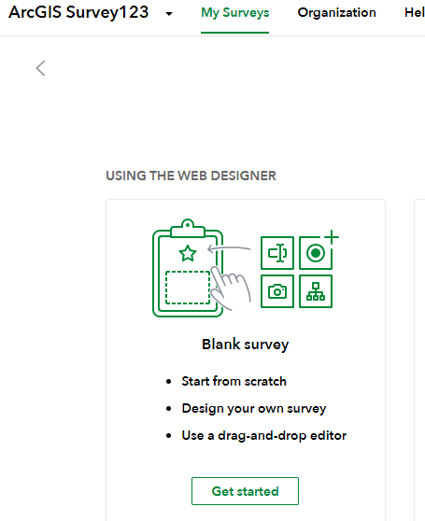
Add a Single Line Text Question with the following settings:
  - Label: Initials
  - Hint: Enter your Initials
  - Validation: Required Question
  - Set Maximum Count to 5 characters
Your first question should look like the image below.
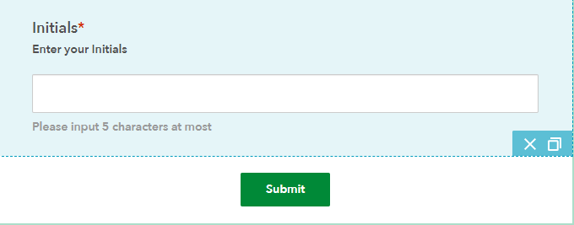
Add another Single Line Question.
  - Recipe
  - Hint: Name of recipe
  - Validation: Required Question
  - Do not create a character limit.

Your second question should look like the image below.
Add another Single Line Question.
- Ingredient
- Hint: Name of the ingredient you are mapping
- Validation: Required Question
- Do not create a character limit.

Your third question should look like the image below.
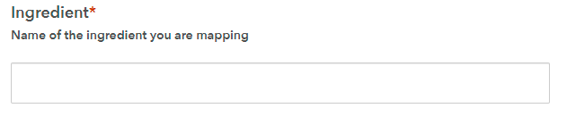
Add a Single Choice Question.
- Label: Which World?
- Hint: Is the recipe a New World or Old World ingredient?
- Create the following choices for students to select:
  - Old
  - New
Your fourth question should like like the image below: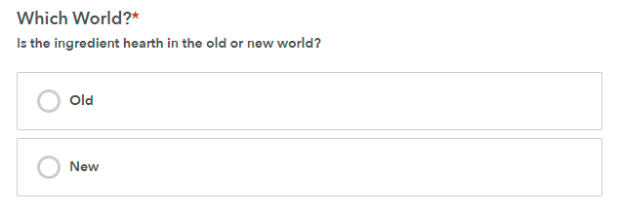
Add a Map Question
- Label: Mapped Location
- Hint: Place a point on the map to correspond with the hearth of this ingredient.
- Drawing Tools: Point
- Map and Extent: Change basemap to Imagery and maintain current extent.
- Validation: Required Question
Your fifth question should look like the image below.
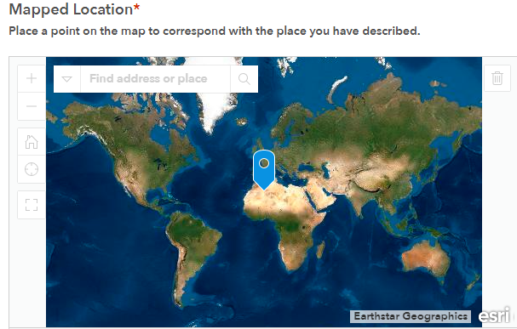

You are now ready to publish and share your survey. To do this:
- Click on Publish -> Publish
- Next, Select Collaborate
- Who Can Submit to this Survey: Everyone
- What can submitters do: Only Add New Records
- Draft Mode: Not Enabled
- Multiple Submission: Allow multiple submissions
- Survey Status: Open: Accepting responses

Save the Settings

Copy the URL for the Survey and share it with your students.
Part II – COLLECT DATA
Share the assignment research document and have students research the geography of a favorite recipe.
*Response times will vary based each teacher’s curriculum, pacing, and classroom realities.
Part III –CREATE A MAP CONTAINING YOUR RESULTS.
Survey123 contains an analyze results section, but I prefer to analyze the results by adding the results layer to an ArcGIS Online Map. To do this:
- Go to www.arcgis.com and sign in to your account.
- Click on Content
- Find the folder, Survey123 created for your Survey.
- Open the Folder and take note of the feature classes created.
- Add the _stakeholder feature layer to an ArcGIS Online Map.
- Save the Map
Suggested ways to analyze student results:
- Filter ingredients by student initials. Have students share their results with each other.
- Create a Heat Map of the ingredients.
- Cluster the features to look for concentrations of ingredients.
- Add the following World Regions layer to the map:
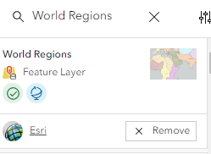
Then have students summarize their data by world region using the Summarize Within tool.
- Have students add a sketch note showing where the recipe originated and then conduct Calculate Travel Cost analysis between the recipe hearth and the recipe’s ingredients.
Directions for options 4 and 5 are provided as optional documents to share with the students.

Assessment:
Students will be assessed based on the accuracy of researching and plotting their ingredients, their StoryMap content and functionality, and their peer review forms.

Student-Facing Resources:
Map that Recipe STUDENT
Name: __________________________________________ Date: _____________________

Map That Recipe – Day 1

Part 1

- Find a copy of the recipe you plan to research.
- Use the internet to research the geographic origin of each ingredient (try to research to the country level) and complete a Survey for each ingredient and recipe hearth. Your recipe needs to have a minimum of 7 ingredients.
- To add an ingredient:
  - Open up the Map That Recipe! Ingredients GeoSurvey provided by your teacher.
  - Complete a survey for each ingredient by entering the following information about the ingredients:
    - Your initials
    - Name of the Recipe
    - Name of the Ingredient
    - Choose Old World or New World
    - Add the marker on the map for the ingredient’s origin.
    - Click “Submit”
  - Refresh your browser and complete a survey for each ingredient.
- Once you are done mapping the ingredients move on to Part 2.

Part 2

- Make a copy of the class’s Ingredients Map
  - Open the map, “Map that Recipe Ingredients Map”
  - Log onto arcgis.com
  - Click “save as”
  - Title it “First Name Last Initial Recipe StoryMap”
  - In the tag box type “Recipe Mapping” and hit enter
  - Save it
  - Filter out your recipe ingredients and recipe
    - Hover over the layer (Ingredients or Recipe Hearth)
    - Click on the “Filter” icon
    - Set the filter so that the initials equal YOUR initials
    - Click “Apply Filter”
  - Save your map
  - Share your map with everyone by clicking on “Share with Everyone”

- Conduct a simple summarize within analysis of your ingredients to create a world regional thematic map of your ingredients. To do this:
  - Click Add Browse Layers (use the ArcGIS Online library)
  - Search for and add the following layer:

  - Click on Analysis -> Tools -> Summarize Within
    - Features to Summarize will be your ingredients
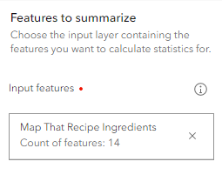
    - Summary areas will be the World Regions layer

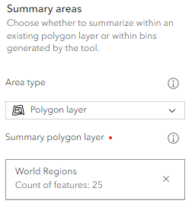
  - Name the Resulting Layer WorldRegionSummary<INITIALS>
  - Choose Run
  - Once the analysis is competed change the symbol style for the WorldRegionSummary layer to Counts and Amounts (color) to show a thematic map of the dominant regions of origin for your recipe. See example below:
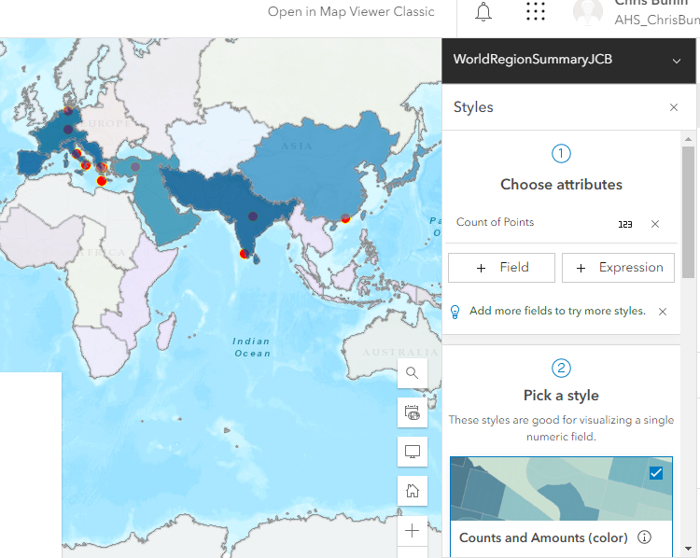

- Add 3-5 Sketch Notes that depict “Did You Know?” facts about your recipe.
  - Research and write down what you want to add to your map note (record your notes in the chart on the next page).
  - Examples: Largest Pizza Ever Created; Earliest Known Pizza Ever Made; Oldest Pizza Restaurant in the United States; Pepperoni was Originally Created in__; etc.
    - To add a Sketch Note, click on Add Create Sketch Layer
    - Choose Vector Point and add a point where you would like on your map.
    - Edit the pop-up information for the point by clicking on Pop up Enable Pop Up
      - Add a Title, Text Information, and additional content (image, website, etc.).
        - Title the pin Fact #1, Fact #2, etc.
        - Type or copy and paste the show description information explaining the interesting fact about your recipe or an ingredient in your recipe
      - OPTIONAL - Add an image to your pop up by finding an image online, right click on the image, choose “copy image address” and paste it into both the “Image URL” and “Image Link URL” boxes. Make sure the address ends in “.jpg, .bmp, .png” or else it will not work. To add the image click on Add Content -> Image. Then paste the image URL address into area
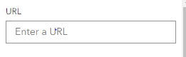

Use the content organizer on the next page to gather interesting information about your recipe to include in your sketch notes.

TITLE | DESCRIPTION | IMAGE and IMAGE LINK

Name: __________________________________________ Date: ____________________

Map That Recipe – Day 2
Creating a StoryMap

1. Open the map that was created and used in the analysis section.
- Hit “SHARE,” select “CREATE A WEB APP,” and then “BUILD A STORYMAP” to commence work on the final lesson deliverable:
  - The StoryMap application that displays the collected data, the GIS analysis via created maps, and subsequent discussion of results and research question answers.

2. Once logged into ArcGIS Online:
- Click “New Story” and select the type of StoryMap you want to create. If you want the most flexibility, try “start from scratch.” If you want a pre-set structure, try the other options.
- Follow the prompts to add information to your StoryMap. Click the green plus sign to add other media, such as maps and videos, or more text to your story.

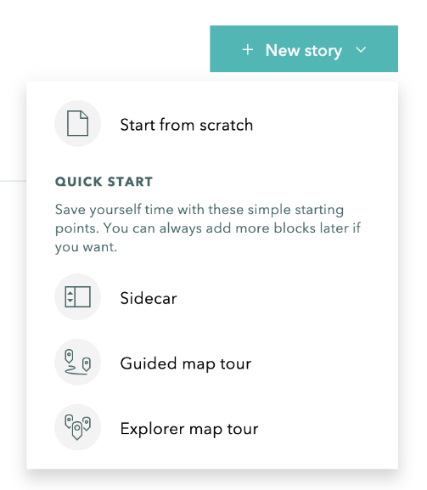
StoryMap requirements:
  - Introduction to your recipe
    - What is your recipe?
    - When were you introduced to it?
    - What is a brief history of the recipe?
  - New World Influences
    - What ingredients come from the New World?
    - What did you find most surprising about your recipe as it relates to the New World?
  - Old World Influences
    - What ingredients come from the Old World?
    - What did you find most surprising about your recipe as it relates to the Old World?
  - Did You Know?
    - Share a few of the interesting facts about the recipe or ingredients in the recipe.
  - Origin to Destination Analysis
    - Show a final slide that shows the recipe connected to its ingredients. In the side panel write a brief statement that summarizes the historical geography of your recipe and how it is connected to the Great Exchange.

General Story Map Tips
- Go to and log into www.storymaps.arcgis.com
- Give your Story Map a Title and Subtitle/description.
- To add a heading tab – Click on ADD+ Textbox
- Type your Text (IE. Background) -> Highlight the text and then change the text to Heading.
- To add a map - Click on ADD+ Map Choose the map you want in the first tab.
- Set the parameters for the first map. To change the parameters for map layers/content click on “custom configuration” next to content. Turn on or off the layers you want to show.
- Continue adding and modifying content to your story map.

Once you finish your StoryMap save it, publish it, and share the link with your teacher.

Name: _____________________________________ Date: ___________________

THREE – TWO – ONE PEER REVIEW

Directions: Go to our class “Recipe Showcase Map.” Choose 3-4 recipes to review and complete a 3-2-1 review for each StoryMap.

Recipe #1: ______________________________________________________

3 Things you learned from this StoryMap
______________________________________________________________________________________________________________________________________________________________________________________________________________________________________________________________________________

2 questions you have about this recipe or its ingredients
____________________________________________________________________________________________________________________________________________________________________________________

1 Compliment for the author of this StoryMap

Recipe #2: ______________________________________________________

3 Things you learned from this StoryMap
______________________________________________________________________________________________________________________________________________________________________________________________________________________________________________________________________________

2 questions you have about this recipe or its ingredients
____________________________________________________________________________________________________________________________________________________________________________________

1 Compliment for the author of this StoryMap

Recipe #3: ______________________________________________________

3 Things you learned from this StoryMap
______________________________________________________________________________________________________________________________________________________________________________________________________________________________________________________________________________

2 questions you have about this recipe or its ingredients
____________________________________________________________________________________________________________________________________________________________________________________

1 Compliment for the author of this StoryMap

Recipe #4: ______________________________________________________

3 Things you learned from this StoryMap
______________________________________________________________________________________________________________________________________________________________________________________________________________________________________________________________________________

2 questions you have about this recipe or its ingredients
____________________________________________________________________________________________________________________________________________________________________________________

1 Compliment for the author of this StoryMap

**OPTIONAL** STUDENT DIRECTIONS TO CALCULATE THE TRAVEL COST OF THE RECIPE

- Open your recipe map
- Research the origin location of your recipe. This is example is using Lasagna which originated in Naples, Italy.
- Add a sketch layer point note at the location of your recipe’s origin. Your map will something like the map below:

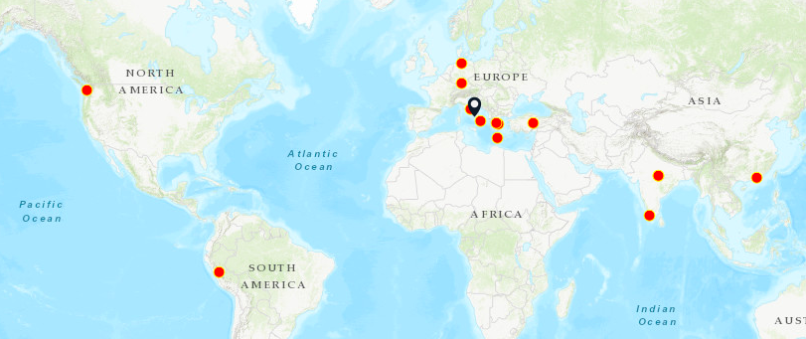

- Click on Analysis Tools Use Proximity Calculate Travel Cost
- Add the from layer (sketch point of recipe origin) and to layer (ingredients). Your layer parameters will look similar to the image below:
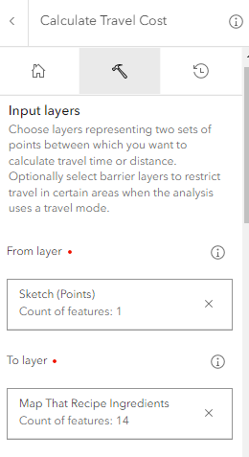
- Set measuring type to line distance
- Name the layer RecipeNetwork<INITIALS>
- Choose Run
- The resulting layer will look similar to the layer below. You can re-symbolize and add this map/layer to your StoryMap to help contextualize the geography of your recipe.

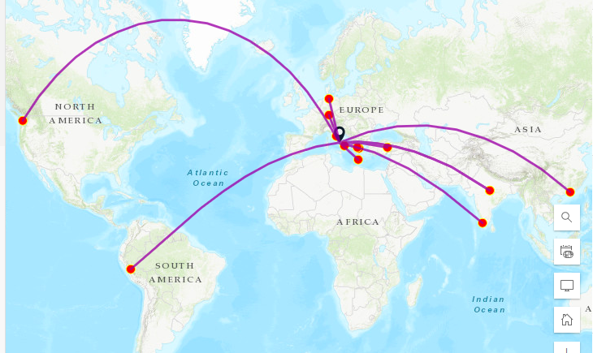
Example of a Calculated Travel Cost for the ingredients of lasagna to the recipe’s origin in Naples, Italy

